**San Francisco Bay University**

**MATH201 - Calculus-I**

**Homework Assignment #2**

**Due day: 6/10/2023**

**Instruction:**

1. **Push the answer sheet to Github in word file**
2. **Overdue homework submission could not be accepted.**
3. **Takes academic honesty and integrity seriously (Zero Tolerance of Cheating & Plagiarism)**
4. Plot each following group of functions in one graph respectively by **Excel**, covering the appropriate domain of *x* and *y.*

$y=e^{x}, y=e^{-x}, y=8^{x}, y=8^{-x}$

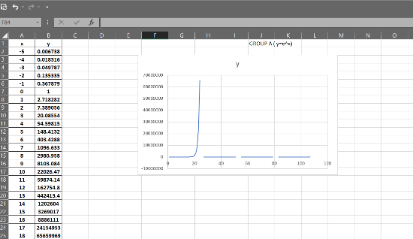

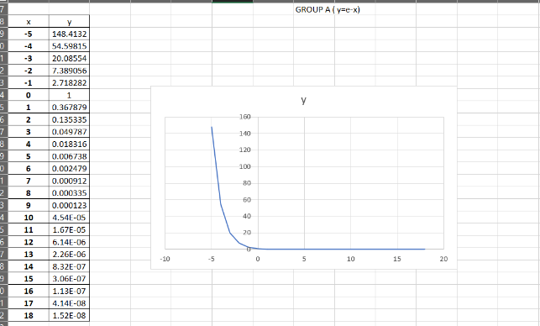

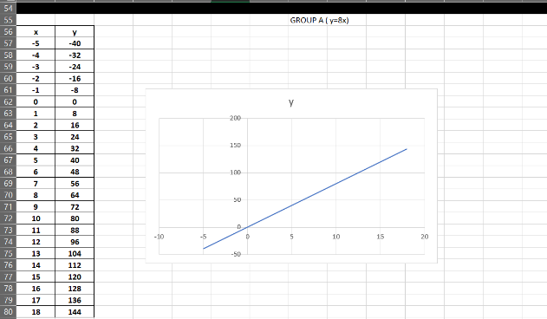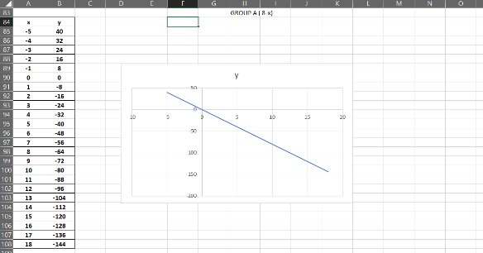

$y={0.9}^{x}, y={0.6}^{x}, y={0.3}^{x}, y={0.1}^{x}$

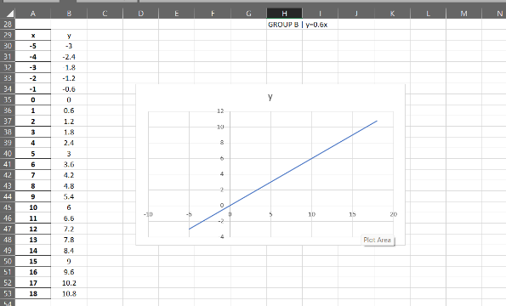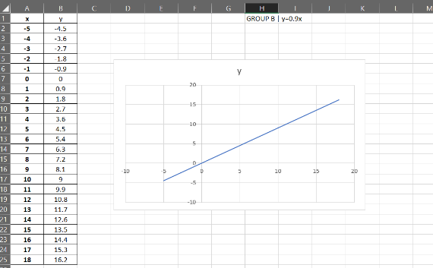

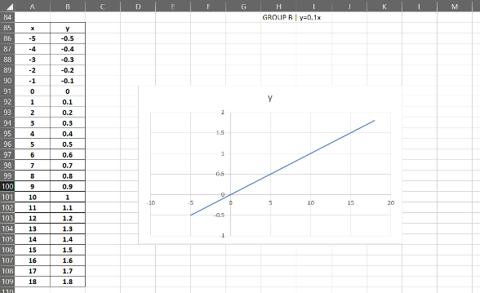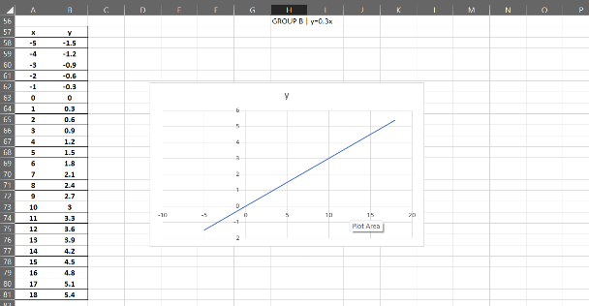

1. Given $f\left(x\right)={10}^{x}$, prove that $\frac{f\left(x+h\right)-f(x)}{h}={10}^{x}(\frac{{10}^{h}-1}{h})$ and verify it by the plot in **Excel.**

Given: f(x) = 10^x

To prove: (f(x+h)-f(x))/h = 10^x ((10^h-1)/h)

Proof:

f(x+h) = 10^(x+h)

f(x) = 10^x

(f(x+h)-f(x))/h = (10^(x+h)-10^x)/h

(10^(x+h)-10^x)/h = 10^x (10^h-1)/h

Therefore, (f(x+h)-f(x))/h = 10^x ((10^h-1)/h)

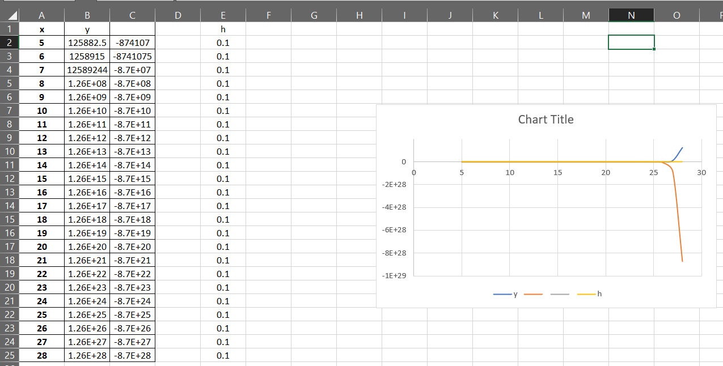

1. Compare the functions $f(x)=x^{5}$ and $g(x)=5^{x}$ by plotting curve in **Excel** and which function grows more rapidly when *x* is large? And prove it mathematically.

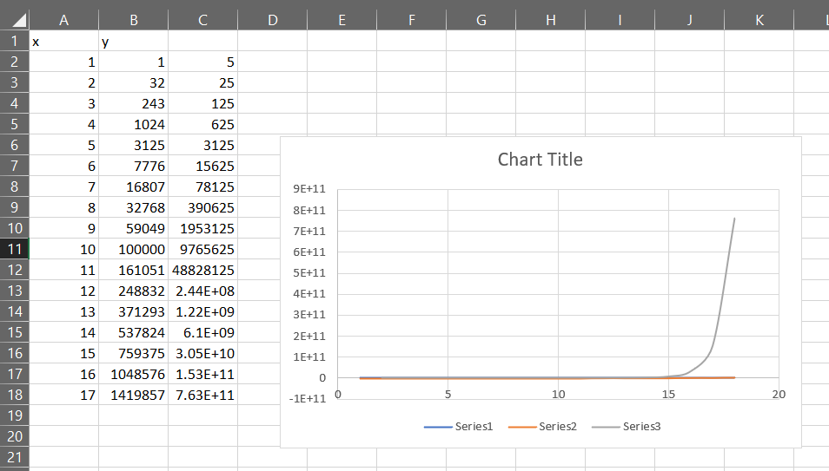

1. Plot the function $f\left(x\right)=\frac{1-e^{1/x}}{1+e^{1/x}}$ in **Excel**. And then prove that $f\left(x\right)$ is an odd function.

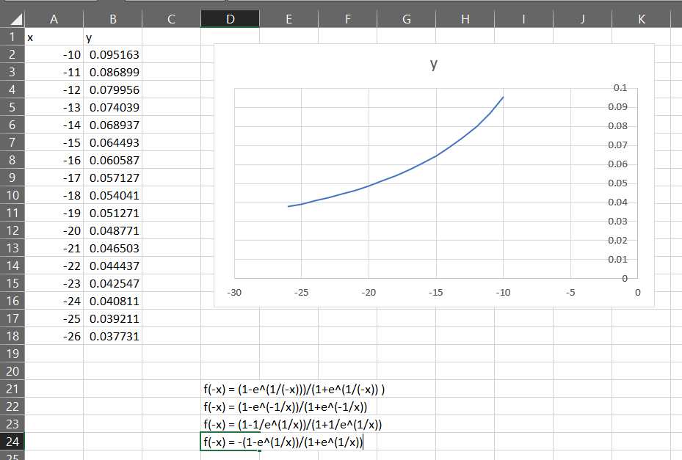

1. For the parametrized function
 $$f\left(x\right)= \frac{1}{1+ae^{bx}}$$

  1. where a > 0. How does the graph change when b changes by showing a group of curves by **Excel**?

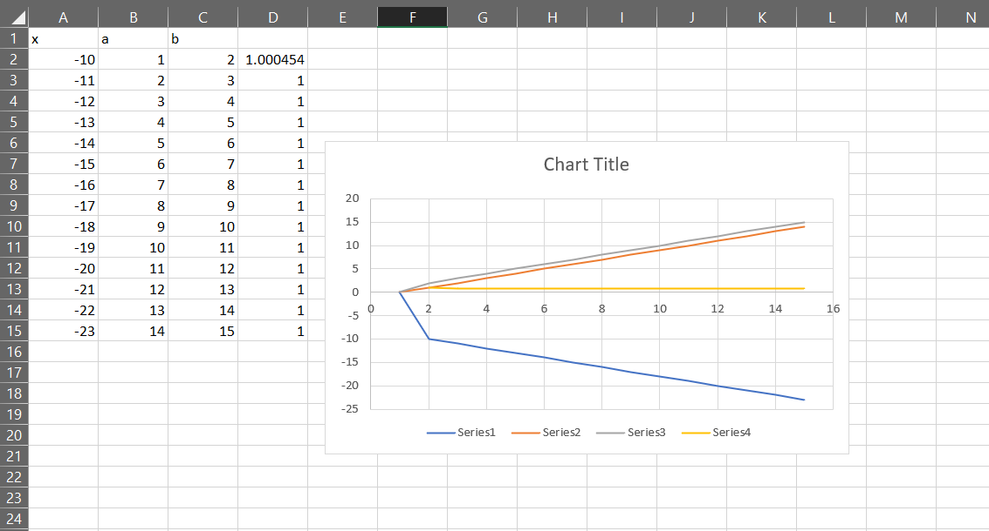

* 1. How does it change when *a* changes in **Excel**?

When a increases the f(x) decreases because the denominator is decreasing as well.

1. If $g\left(x\right)=x^{6}+ x^{4}, x≥0$, find $g^{-1}(x)$ expression. And that, plot $y=g\left(x\right), y=x,$ and ${y=g}^{-1}(x)$ in one graph by **Excel**

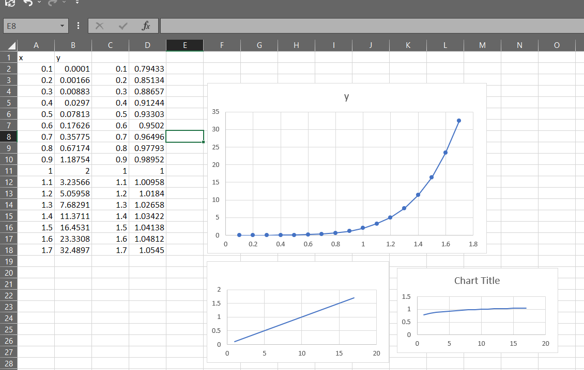

1. When a camera flash goes off, the batteries immediately begin to recharge the flash’s capacitor, which stores electric charge given by

$$Q\left(t\right)=Q_{0}(1-e^{-t/a})$$

(The maximum charge capacity is $Q_{0}$ and t is measured in seconds.)

* 1. Find the inverse of this function and explain its meaning.

The inverse of this function is t= -a ln(1-y/Qo)

This is the amount of time it takes for the capacitor to change.

* 1. How long does it take to recharge the capacitor to 90% of capacity if a = 2 showing in the plot by **Excel**?

